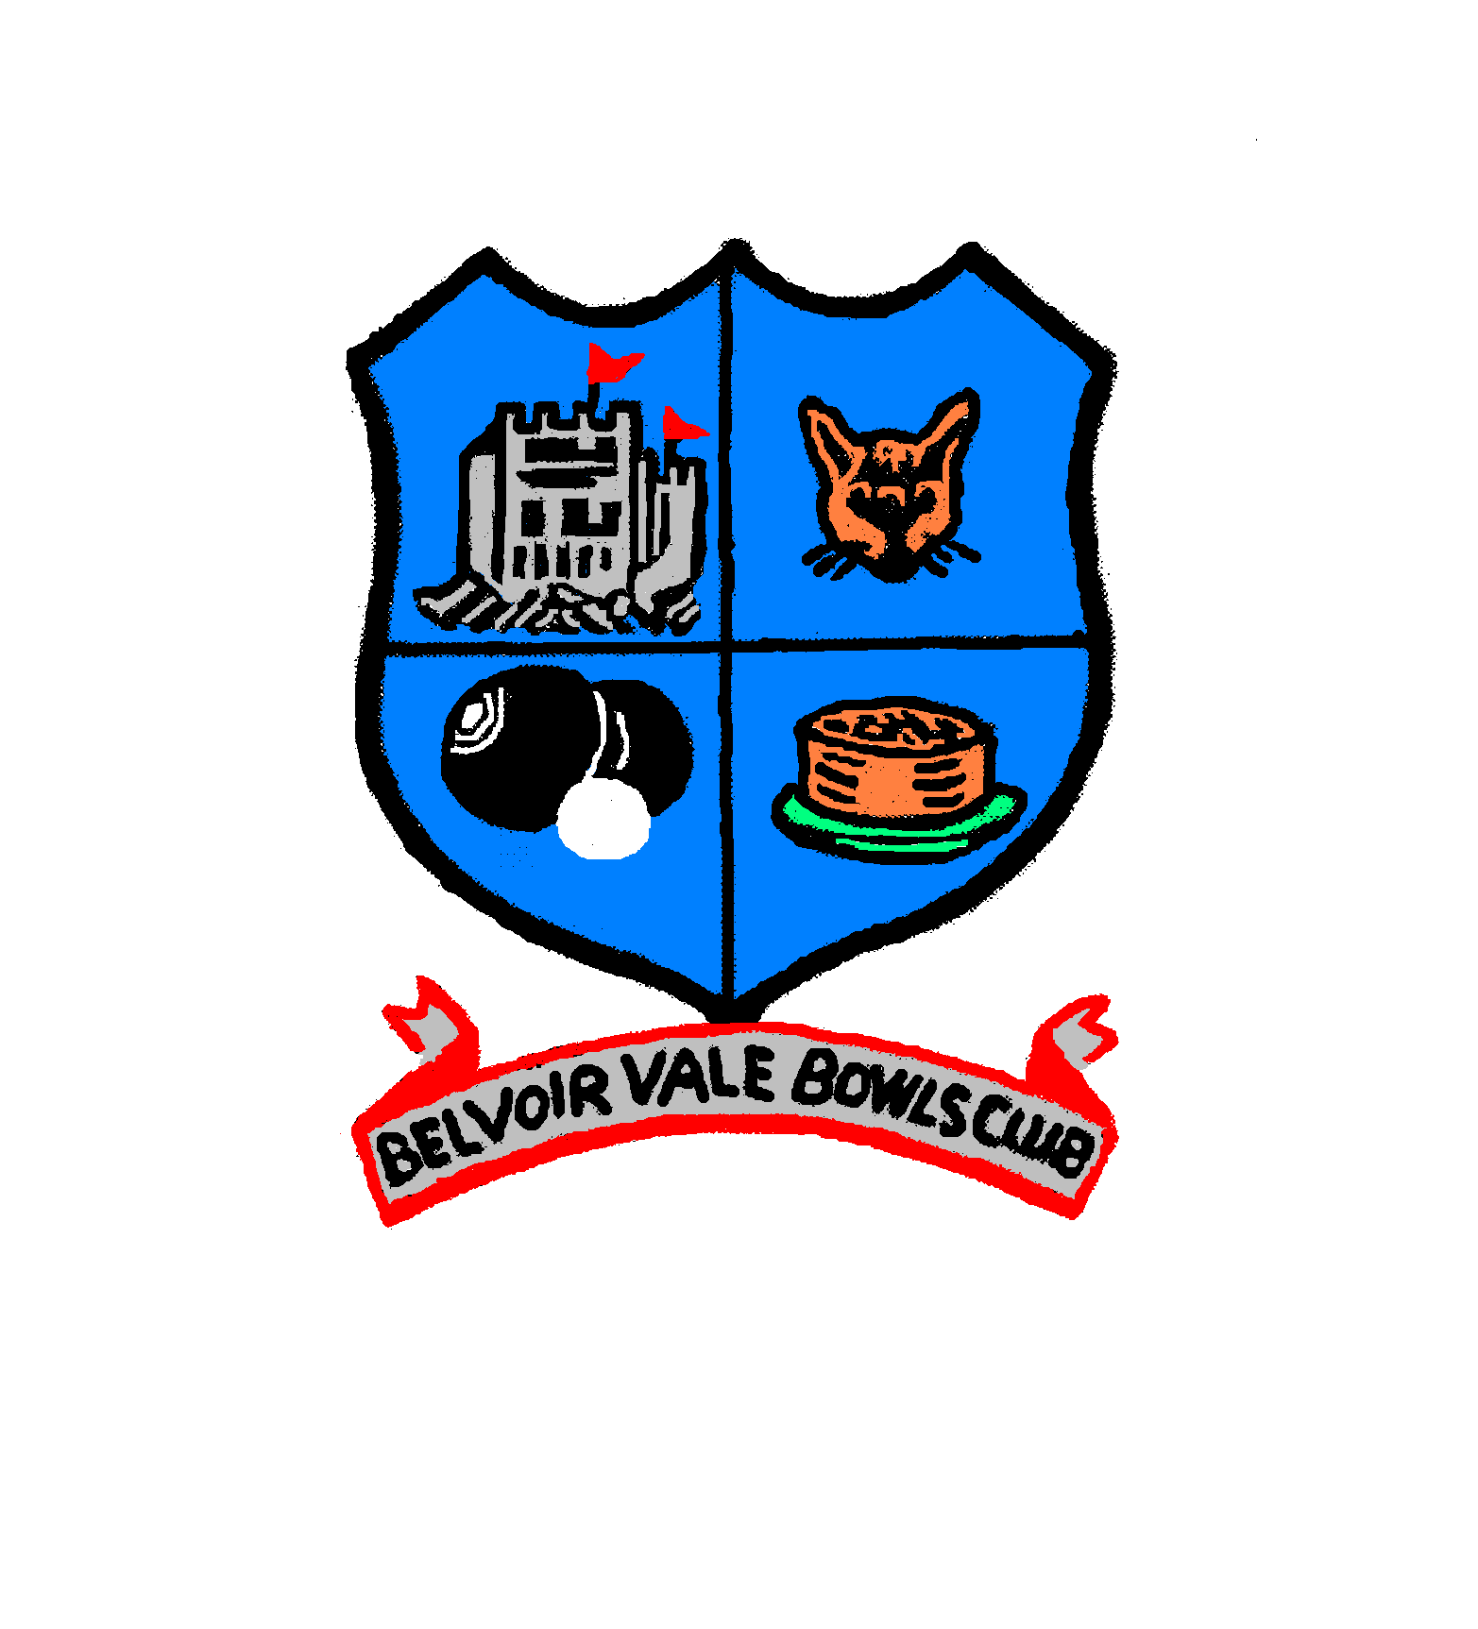
BELVOIR VALE BOWLS CLUB
Membership Application 2025

Please complete this form and hand in at the club house on Tuesday 18th March at 7.00pm or, if you can’t attend, return it by post or email to Sarah Porter before then.
Name:
Address:
Contact: | Tel: Mobile:
Email address:
Date of birth:
Gender:
Ethnicity:
In case of emergency contact | Name: Relationship:
 | Tel: Mobile:
Most recent occupation:

Health and/or Medical Conditions
Are any of the health issues relevant to you? (Please tick all that apply):

- Visual (e.g. partial sight or blindness)
- Hearing (e.g. partial hearing or deafness)
- Mobility issues (e.g. difficulty walking short distances, climbing stairs & carrying objects)
- Stamina or breathing difficulty
- Dexterity difficulties (e.g. difficulty lifting, grasping or holding objects)
- Long term pain or discomfort that is always present or reoccurs from time to time
- Other long-standing illness or disability
- Prefer not to say
- None of the above

*I am willing to receive club emails from Belvoir Vale Bowls Club Yes/No
*I am willing for my image to be used in club promotional material Yes/No
* Delete as applicable

By completing this form, you consent to being added to our mailing list to receive regular information about our club and activities. Your personal data will not be used for any commercial gain, passed onto any commercial providers or to any third-party organisation outside of local bowls leagues. More information can be found in the BVBC Privacy Notice obtainable from the secretary.

Please sign to confirm you agree with the above:______________________________

