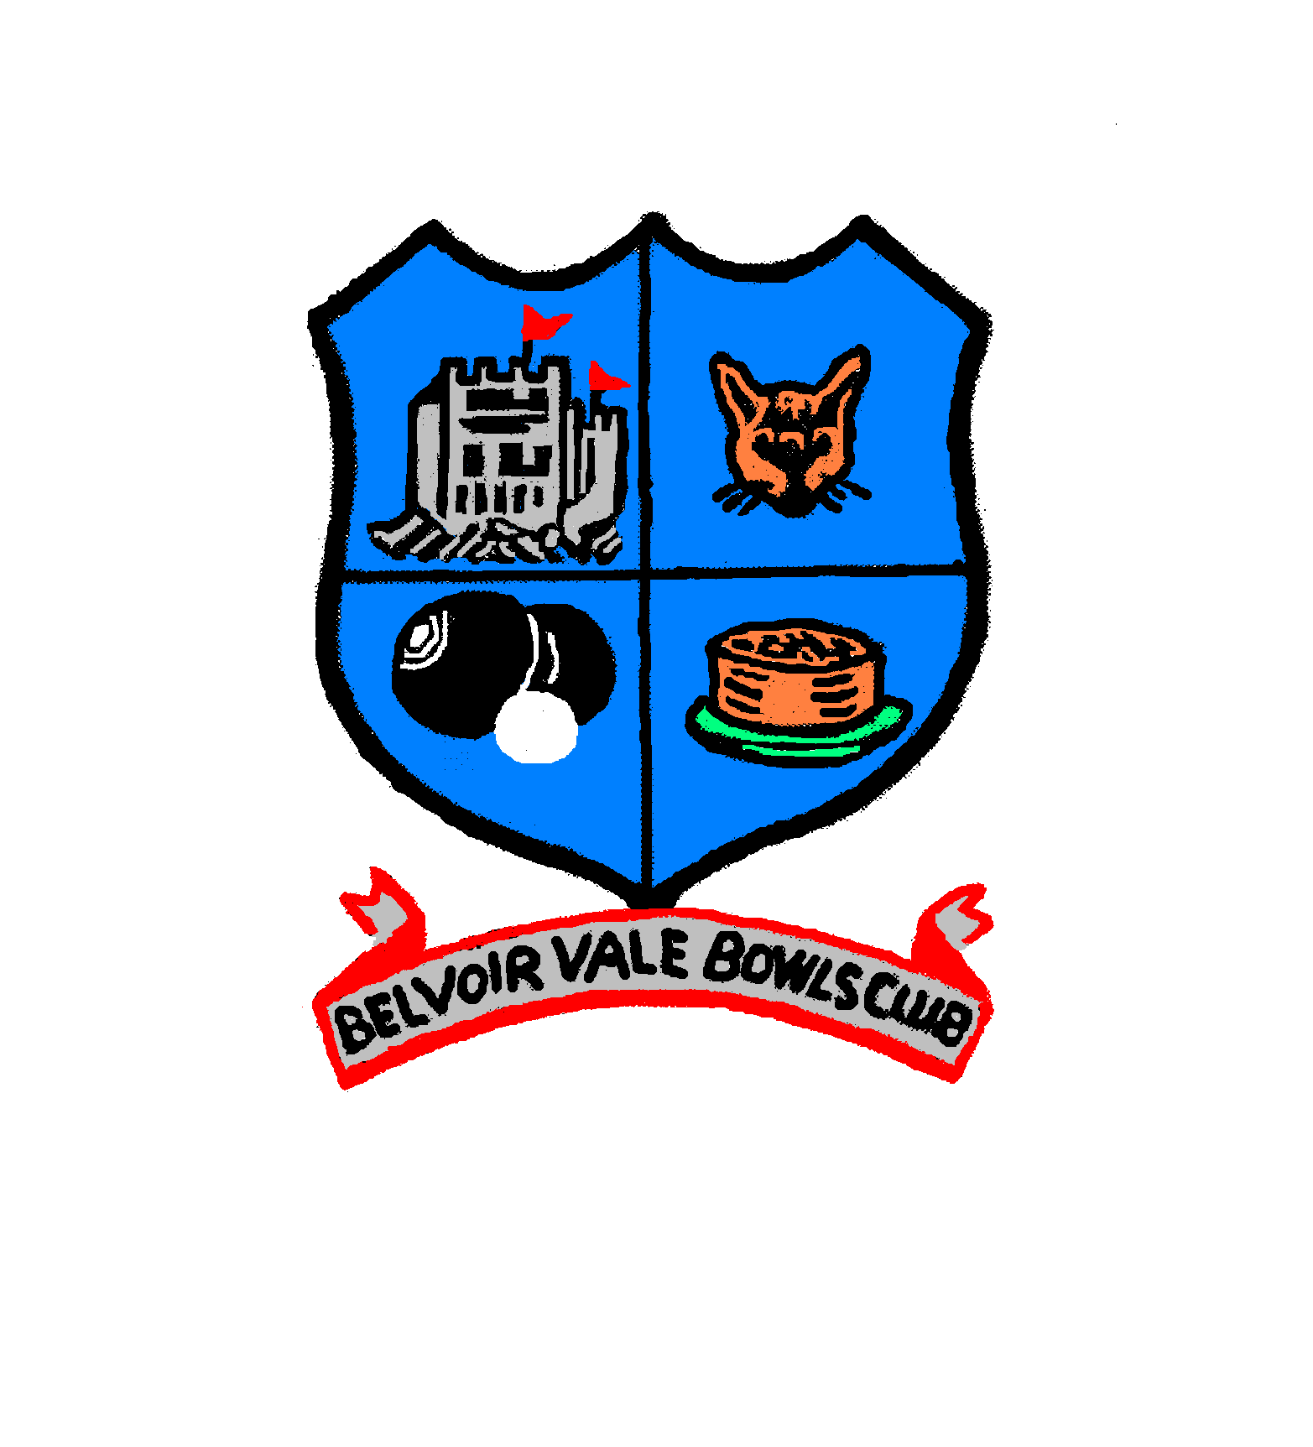
Belvoir Vale Bowling Club
Mount Pleasant, Hose, Nr Melton Mowbray, Leics LE14 4JX

RINKS GALA

MONDAY 25TH AUGUST 2025

You are invited to enter a mixed team(s) in our Gala on the above date,.

The entrance fee is £15 per person(£60 per team) and this includes tea/coffee and biscuits on arrival, lunch and tea and cakes at the end of the day
Cash prizes:-Winning Team £120, Runners-up £80
Dress is greys and registration is at 9am or 10am depending on your start time of 9.15 or 10.15.

Gala Format;-

- EBA rules
- Each team play 3 games of 8 ends and 1 game of 10 ends.
- Scoring:-Win-4pts, Draw-2pts and 1pt for each end won, in the event of a tied end ½ pt to each team.
- Score cards to be handed in at the end of each game.
- In the event of adverse weather conditions causing play to be abandoned scores will be counted up to where all teams have played an equal number of games

Please detach the entry form below and return it together with your remittance by post to Mr L Pugh, 7 Dalgliesh Way, Asfordby, Melton Mowbray, Leics. LE14 3RX or by email to lcpugh@talktalk.net by 30th June 2025

Payments preferably by BACS HSBC Bank Account Belvoir Vale Bowling Club
Sort code 40-32-14 Account Number 21222953, or by cheque made payable to
Belvoir Vale Bowling Club

Guests are welcome to join in lunch & tea @ £10.00 per person, please include numbers with your entry form and advise of any dietary requirements.

…………………………………………………………………………………………………………………………

Entry Form

Team Name:-……………………………….. Club:-…………………………………………

Contact Name:-……………………………….Tel No:-………………………………………

Email address:-…………………………………………………………No of Guests:-.......

Total Payment:-£....... How paid cheque or bank transfer(with surname as ref.)

